Exercise 6: Node and Express (P2)

Objective
In this exercise, you'll learn how to organize your Express application by separating routers into different files. This approach enhances the maintainability and scalability of your application, especially as it grows.

Exercise 1
- From the results of app in part 1, create routes folder
- Create file articleRouter.js in routers folder
- Create all routes in articleRouter.js file and call it in app.js file

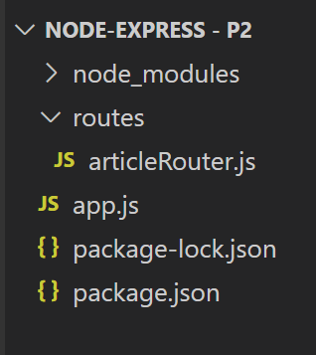

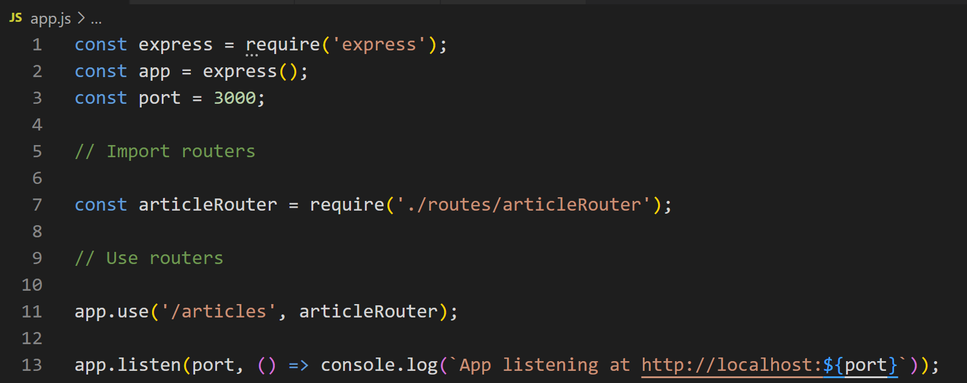

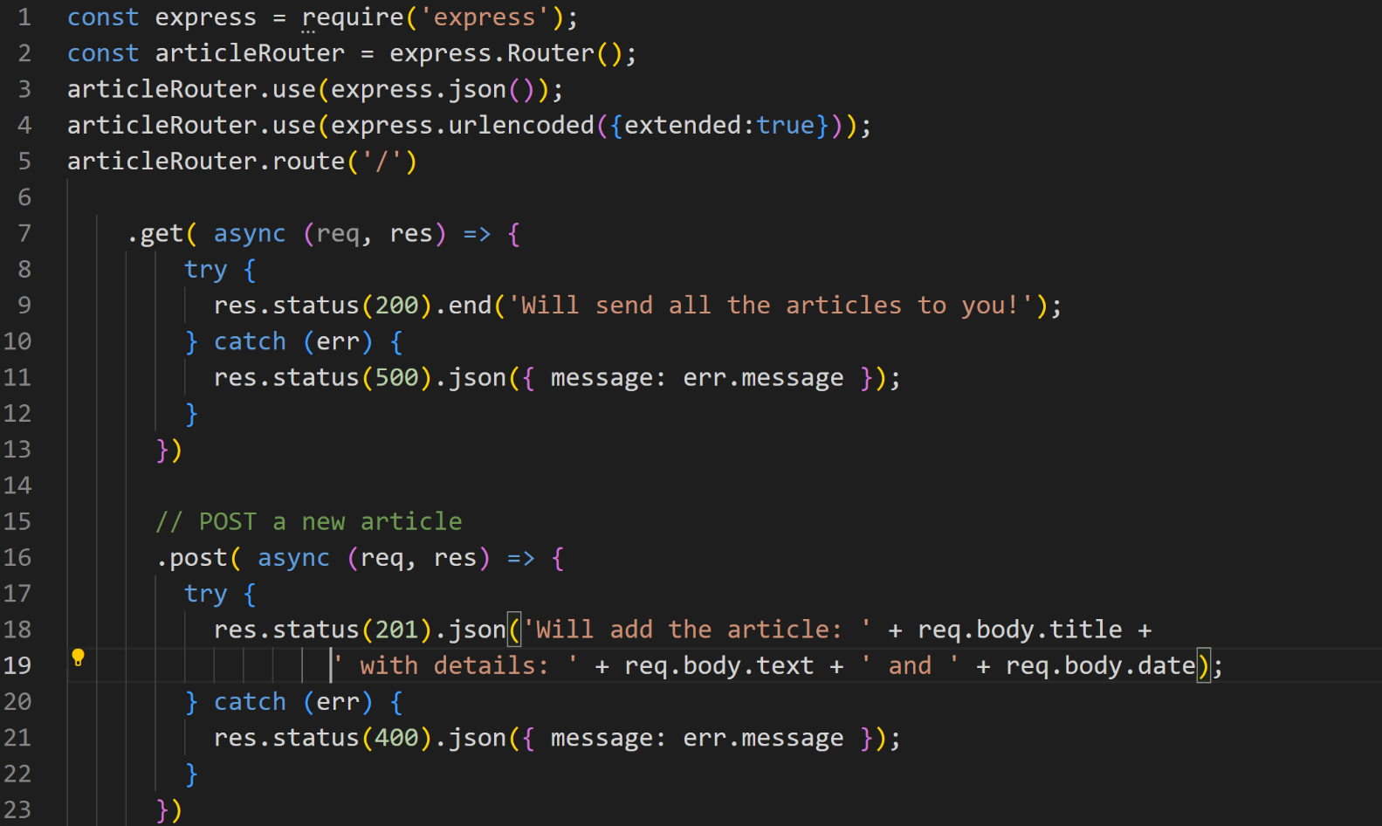
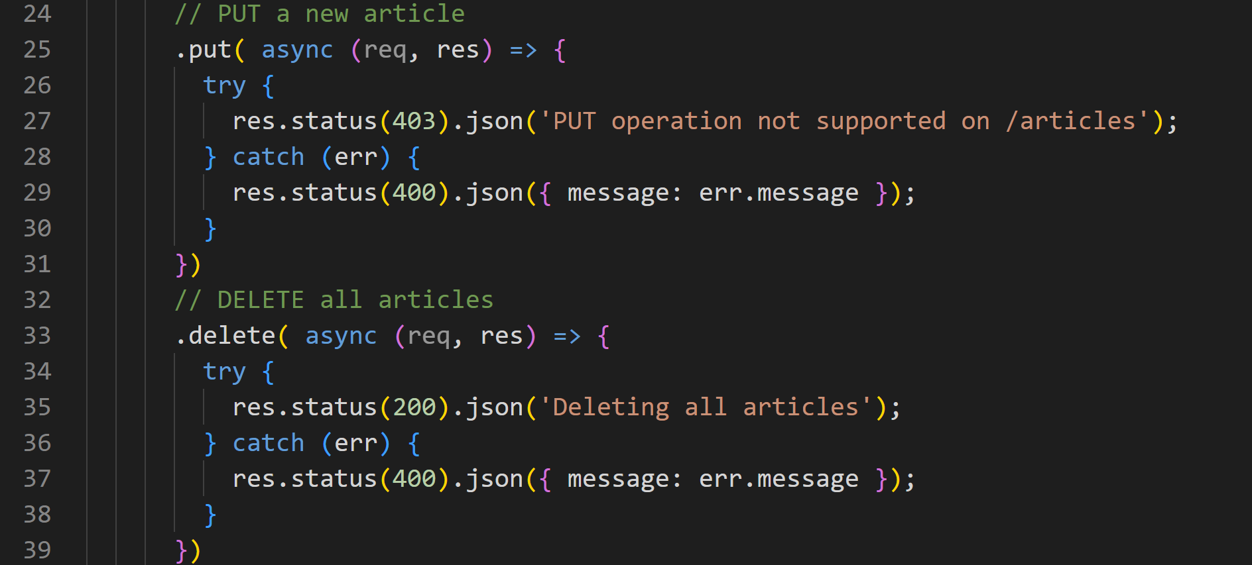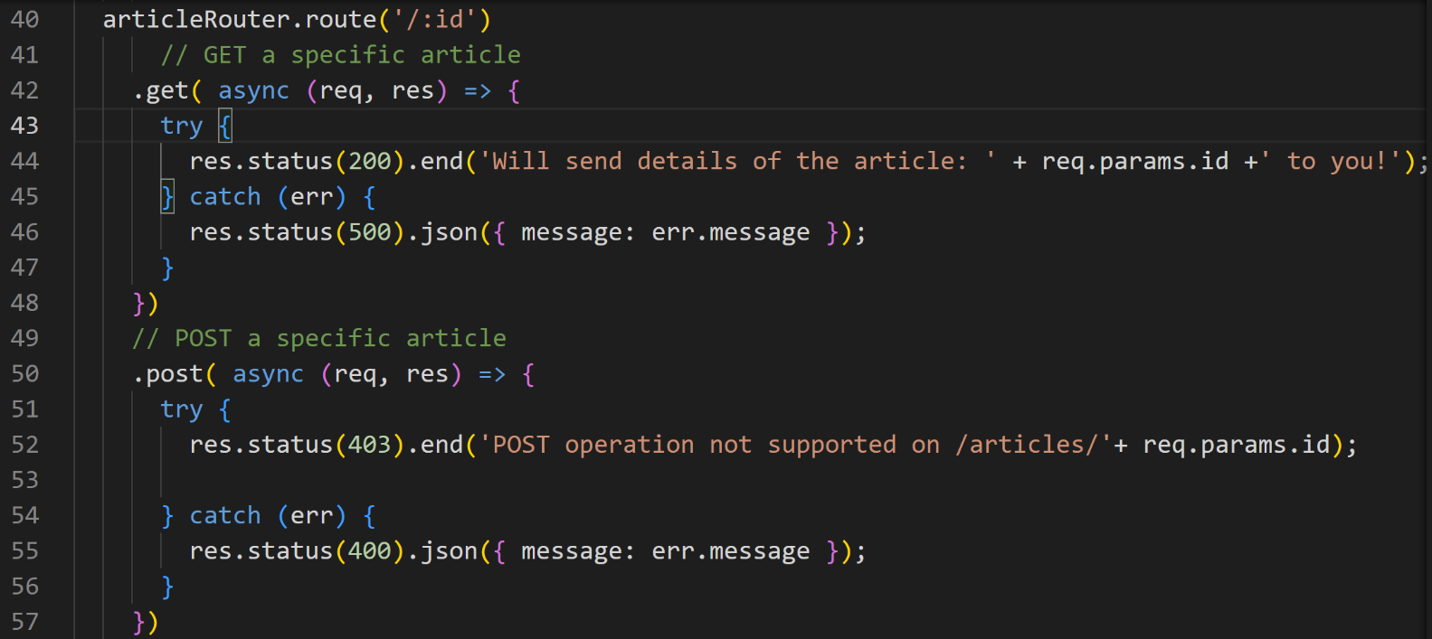
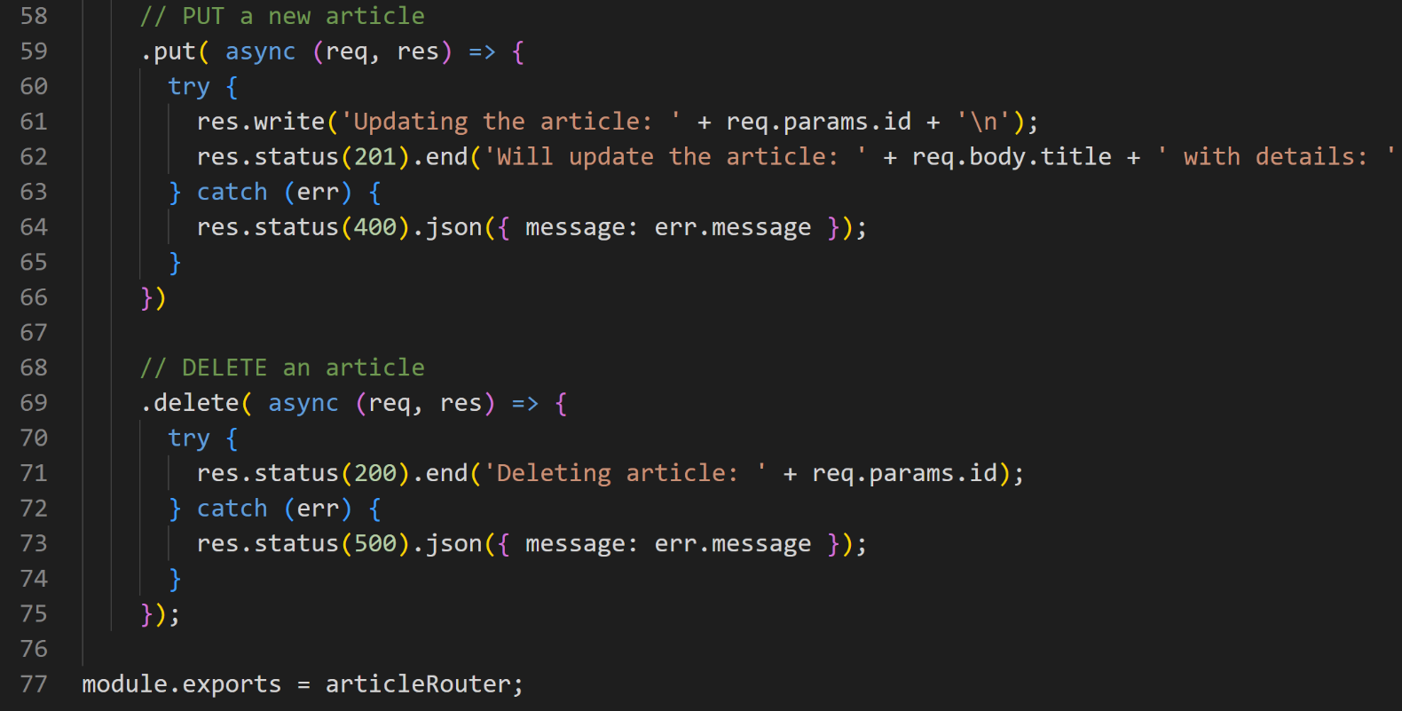

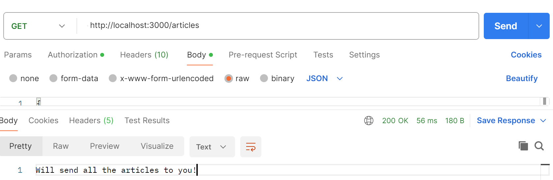

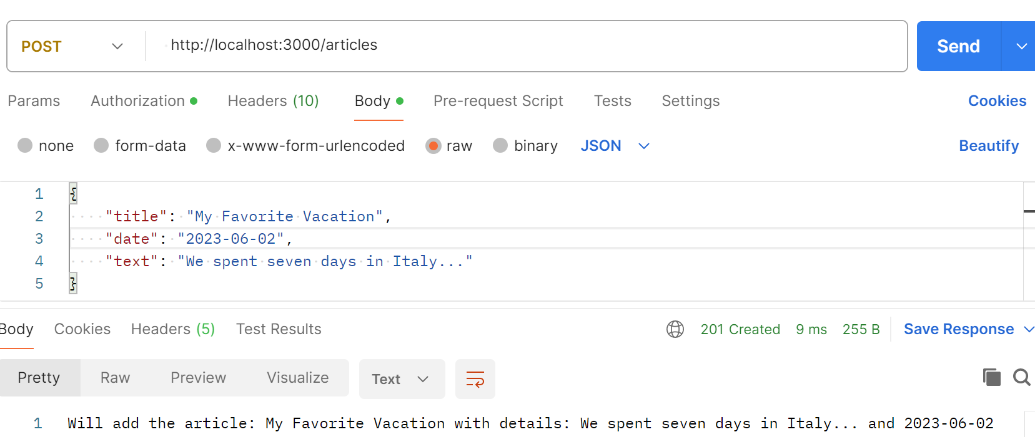

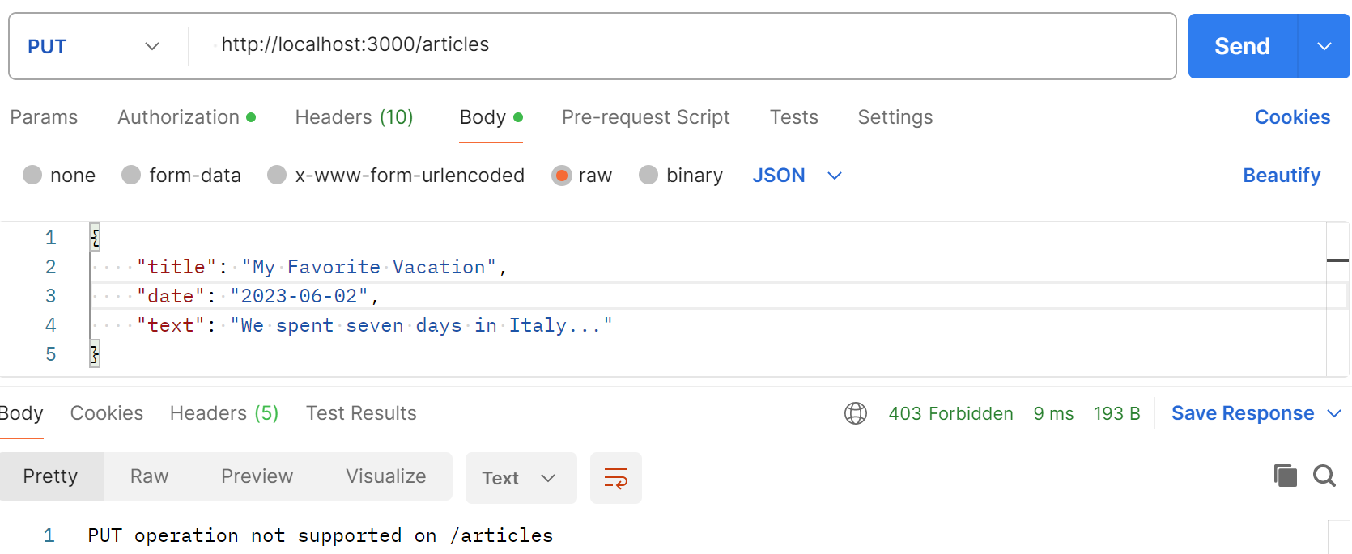

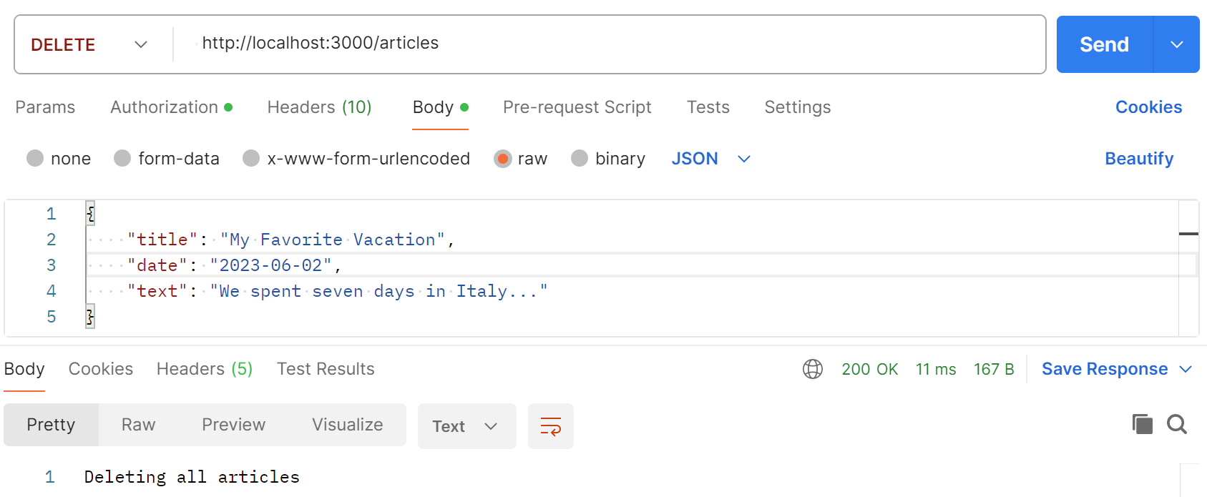

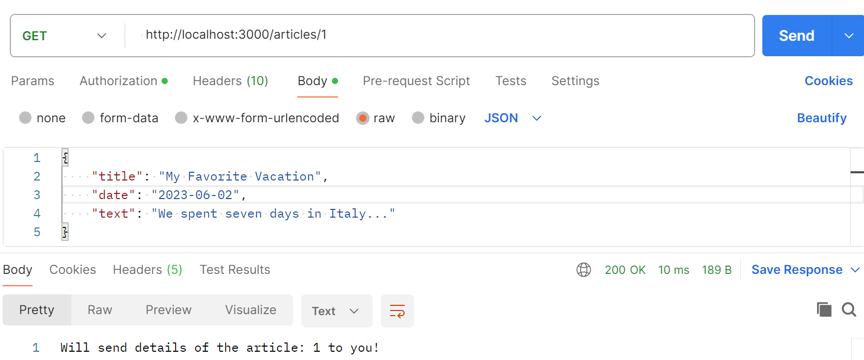

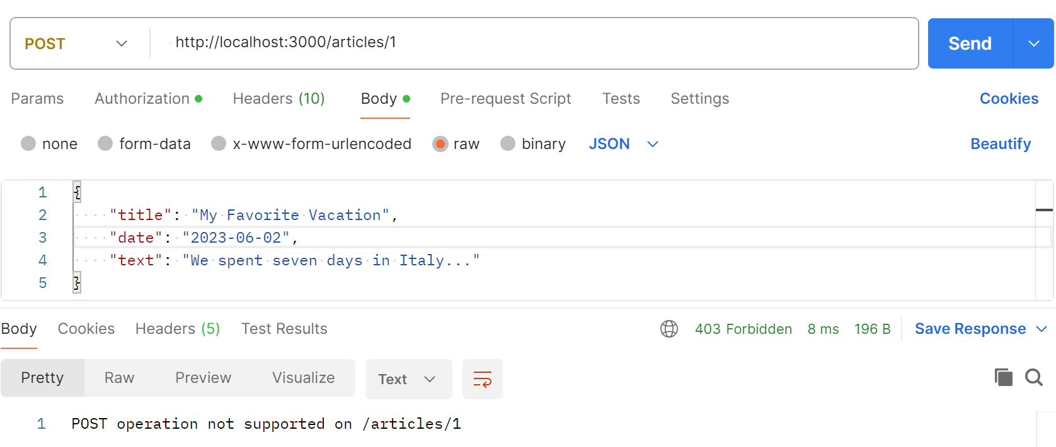

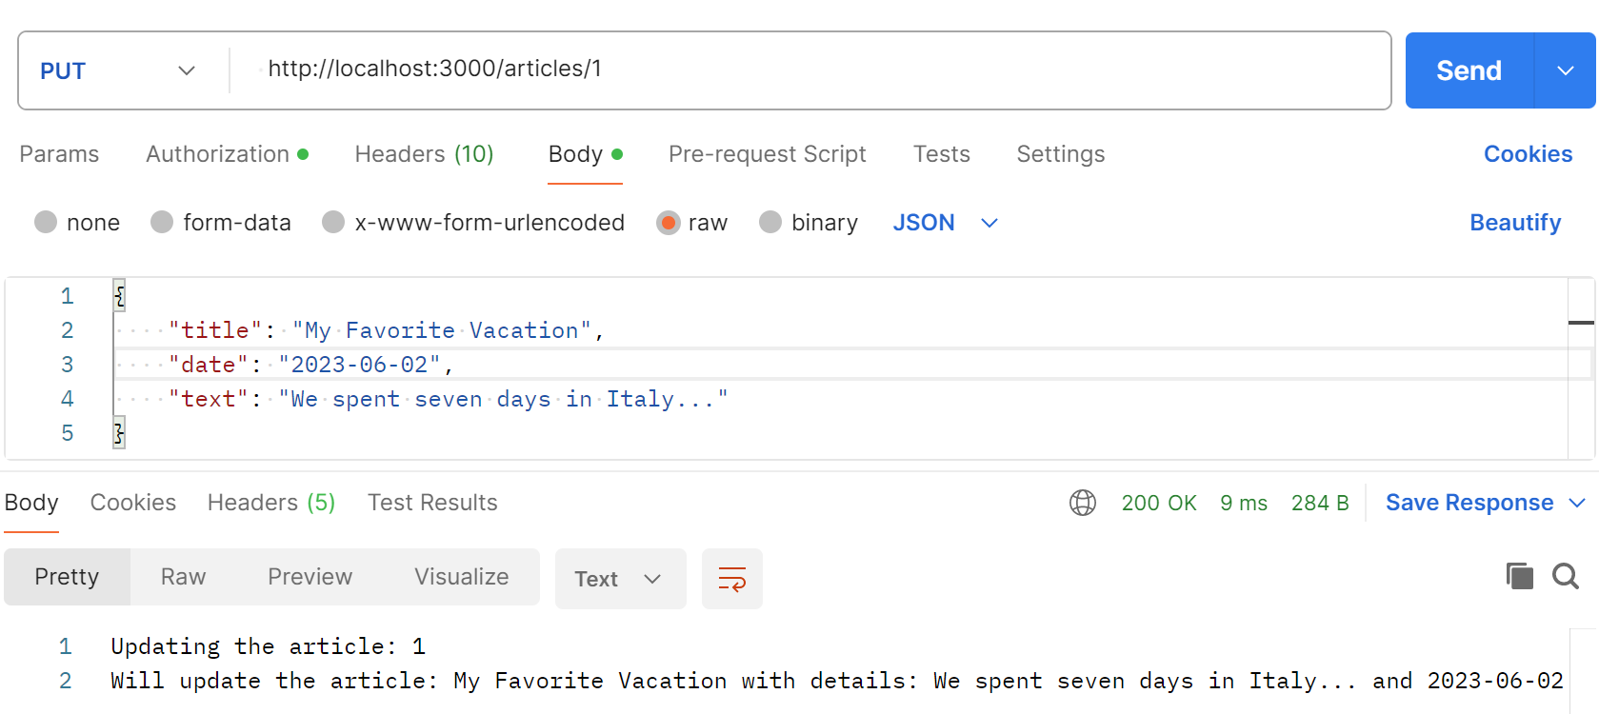

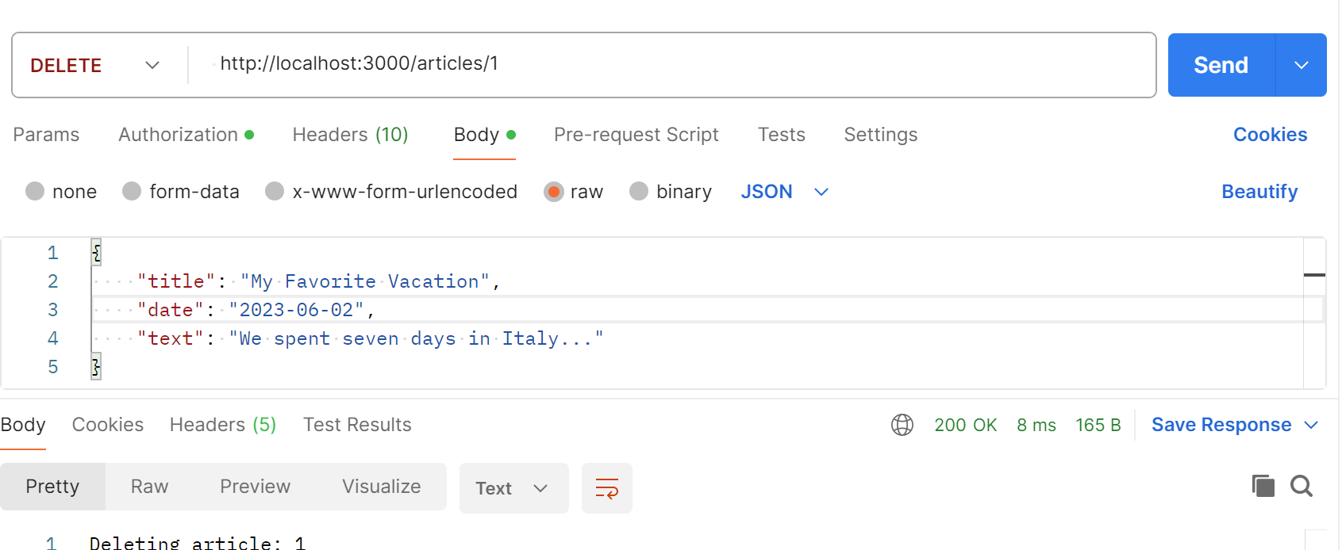

Exercise 2
- In node-express, create file videoRouter.js in routers folder
- Create all routes in videoRouter.js file and call it in app.js file

Conclusion
This exercise aims to deepen your understanding of how to build separating routers into different files with Express framework.

